Reviewed 6/6/2017

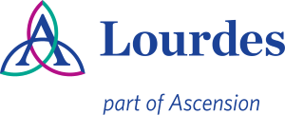

Department of Pathology and Laboratory Medicine

ACCREDITATION INFORMATION:

College of American Pathologists (CAP)
Accreditation Number: 12715-01

New York State Department of Health (NYSDOH)
Clinical Laboratory Permit
1922 0301701

Clinical Laboratory Improvement Act (CLIA)
I. D. Number: 33D0168541

Electronic Authorizations:

Michael Zur, MD, Medical Director of Laboratory

Kelly Cwikla, MT(ASCP)SM, Clinical Manager of Microbiology

