**LOURDES HOSPITAL**

**169 Riverside Drive**

**Binghamton, New York 13905**

**LAB MANUAL**

______________________________________________________________________________

**SUBJECT: Rapid Influenza A&B Test using ORIGIN DATE: 08/01/2014**

**B-D Veritor System**

**Reviewed: 8/30/2021 Revised: 6/6/2017,1/30/2018,2/28/2019,11/12/2019**

**____________________________________________________________________________________________**

**General Information**:

Influenza A and Influenza B are very serious, contagious disease that can spread rapidly throughout hospital and nursing home settings. Rapid detection of these pathogens is beneficial to patient care and from an epidemiological standpoint.

**Principles of the Test**

The BD Veritor System for Rapid Detection of Flu A+B is a chromatographic assay to qualitatively detect influenza A and B viral antigens in samples processed from respiratory specimens. When specimens are processed and added to the test device, influenza A or B viral antigens bind to anti-influenza antibodies conjugated to detector particles in the A + B test strip. The antigen-conjugate complex migrates across the test strip to the reaction area and is captured by the line of antibody on the membrane. A positive result for influenza A is determined by the BD VeritorSystem Reader when antigen-conjugate is deposited at the Test "A" position and the Control "C" position on the BD VeritorSystem Flu A+B assay device. A positive result for influenza B is determined by the BD Veritor System Reader when antigen-conjugate is deposited at the Test "B" position and the Control "C" position in the BD VeritorSystem Flu A+B assay device.

A negative result is determined when complexes are deposited only in the control area.

**Competency and Training:**

The Veritor Influenza A&B assay is a Waived Point-of-Care test to aid in the diagnosis of infection with Influenza A or B.

Associates will be trained and competencied by one of the designated trainers on initial hire, again at six months and then yearly during their annual competency with a hands on demonstration of their ability to run both QC and patients. Any associates with appropriate training and competency assessment can perform testing.

**Specimen requirements:**

Acceptable specimens are either a nasal or nasopharyngeal (NP) swab collected with the flocked swab included in the kit. Specimens should be processed within one (1) hour of collection. NP swabs are favorable to nasal swabs for recovery of influenza virus and should be used whenever possible. Nasal swabs should be reserved only for cases where the patient cannot tolerate an NP collection.

**Reagents and Materials**

1. BD Rapid Influenza A and B test kit (cat#256041) which includes:
   1. Test Devices—Foil pouched device containing one reactive strip. Each strip has two test lines of monoclonal antibody specific to either Flu A or Flu B influenza viral antigen and murine monoclonal control line antibody.
   2. RV Reagent C —Detergent with <0.1% sodium azide. 30 /400ul tubes
   3. Flexible minitip flocked swab-for nasopharyngeal or nasal collection. 30 swabs
   4. Control A+/B- swab : Inactivated Influenza A antigen with <0.1 sodium azide
   5. Control A-/B+ swab: Inactivated Influenza B antigen with <0.1 sodium azide
2. Veritor Reader (Cat# 256055)* Useable for 3000 test reads only or for 2 years from activation whichever occurs first.
3. BD Veritor™ System Flu A+B Control Swab Set, 10 pairs of swabs Timer(Cat#256051)
4. Tube rack for specimen testing

**STORAGE**

Kits can be stored at 2-30 C (DO NOT FREEZE) and are acceptable for use until the expiration date. Do Not use past expiration date.

Reagents and devices must be at room temperature (15-30 C) before testing.

IDENTIFICATION and LABELING: the patient will be identified using 2 identifiers, patient full name and date of birth and the swab and test device will be labeled with the 2 identifiers.

QUALITY CONTROL: Control material is provided with the kit (additional controls are purchased). Controls are to be performed once with each new kit.

**Internal**

Each BD Veritor System Flu A+B device contains both positive and negative internal/procedural controls:

1. The internal positive control validates the immunological integrity of the device, proper reagent function, and assures that the correct test procedure was followed.
2. The membrane area surrounding test lines functions as a background check on the assay device.

These positive and negative internal/procedural controls are evaluated by the BD Veritor System Reader after insertion of the BD Veritor System test device. The BD Veritor System Reader will prompt the operator should a quality issue occur. Failure of the internal/procedural controls will generate an invalid test result.

***External***

Swab controls (Flu A positive/B negative and Flu B positive/A negative) are supplied with each kit with additional controls purchased from BD

Positive and Negative controls are run once with each new kit.

**Do Not Report Patient Results Unless QC is acceptable**

COLLECTION- A fresh nasal or nasal pharyngeal swab collected using proper technique using the swabs included in the kit.

* + - Freshly collected specimens should be processed within **1** hour.
    - It is essential that correct specimen collection and preparation methods be followed. ( refer to Collection Procedure )
    - Specimens obtained early in the course of the illness will contain the highest viral titers.

.TEST PERFORMANCE

**Quality Control Testing Procedure**

1. For each control swab, remove one RV Reagent C tube/tip and one BD Veritor System Flu AB device from its foil pouch immediately before testing.
2. Label one BD Veritor System Device and one RV Reagent D tube for each control to be tested.
3. Place the labeled RV Reagent C tubes in the designated area of the tube rack
4. Remove and discard the cap from the RV Reagent C tube corresponding to the sample to be tested.
5. For control insert the control swab into the labeled tube and vigorously plunge the swab up and down in the fluid for a minimum of 15 seconds. Remove the swab while squeezing the sides of the tube to extract liquid from the swab
6. Press the attached tip firmly onto the RV Reagent C tube containing the processed specimen or control. NOTE: DO NOT USE any other tip from any other product
7. Invert the RV Reagent C tube and hold the tube vertically (approximately one inch above the BD Veritor System device sample well). Holding the tube at the ridged area, squeeze gently allowing 3 drops of the processed sample to be dispensed into the sample well of the corresponding device. NOTE: Squeezing the tube too close to the tip can cause leakage.
8. After adding the sample, allow the test to run for 10 minutes before inserting into the reader.
9. Turn the BD Veritor Reader on. NOTE: The BD Veritor Reader can only perform 3000 determinations. If the reader indicates that the volume is high notify manager immediately and insure that there is a backup reader.
10. At the end of 10 minutes insert the BD Veritor System Flu AB device into the system. Insure that the reader indicates that it is ready for device insertion.
11. Follow the reader prompts to complete the procedure and obtain test results
12. Record the results on the log sheet

**Patient Testing procedure**

1. For each patient specimen, remove one RV Reagent C tube/tip and one BD Veritor System Flu A+B device from its foil pouch immediately before testing.
2. Label the BD Veritor System Device and one RV Reagent C tube for each specimen to be tested.
3. Place the labeled RV Reagent C tubes in the designated area of the tube rack.
4. Remove and discard the cap from the RV Reagent C tube corresponding to the sample to be tested.
5. Place the freshly collected nasal swab labeled with 2 patient identifiers into the corresponding labeled RV Reagent C tube and swirl vigorously against the inside wall three (3) times.
6. Remove the swab while squeezing the sides of the tube to extract the liquid from the swab. Discard the swab after use.
7. Press the attached tip firmly onto the RV Reagent C tube containing the processed specimen. NOTE: DO NOT USE any other tip from any other product.
8. Invert the RV Reagent C tube and hold the tube vertically (approximately one inch above the BD Veritor System device sample well). Holding the tube at the ridged area, squeeze gently allowing three (3) drops of the processed sample to be dispensed into the sample well of the appropriately labeled test device. NOTE: Squeezing the tube too close to the tip can cause leakage.
9. After adding the sample, allow the test to incubate for 10 minutes before inserting into the reader.
10. Turn the BD Veritor Reader on. NOTE: The BD Veritor Reader can only perform 3000 determinations. If the reader indicates that the volume is high notify manager immediately and insure that there is a backup reader.
11. At the end of 10 minutes insert the BD Veritor System Flu AB device into the system. Insure that the reader indicates that it is ready for device insertion .Follow the reader prompts to complete the procedure and obtain the test results.
12. Record the test results on the log sheet and the patient chart copy form

RESULT INTERPRETATION The BD Veritor System Reader instrument must be used for all interpretation of test results. Operators should not attempt to interpret assay results directly from the test strip contained within the BD Veritor System Flu A+B assay device

**Positive for Influenza A**—The reader will display FLU A+, FLU B - Positive results are also reportable to the health department. **\*NOTE:** All positive tests are documented on the NYS Communicable Disease Log and sent to the NYS Health Department weekly

**Positive for Influenza B**—The reader will display FLU A-, FLU B +. Positive results are also reportable to the health department. **\*NOTE :** All positive tests are documented on the NYS Communicable Disease Log and sent to the NYS Health Department weekly

**Negative**—The reader will display FLU A-, FLU B-. Please place specimen in viral transport media for possible send out to a reference lab.

**Invalid**—The reader will display RESULT INVALID or CONTROL INVALID. In this case the test can be repeated to see if a better result can be obtained. If repeating is still invalid send a viral culture.

RESULT REPORTING:

Patient results are not reported unless the quality control is acceptable. The patient’s results must be recorded in the patients chart, using the Laboratory Result/Order Form as well as on the accession log with patient’s name, date of birth, the date and time of the test, and signature of the person performing the test. The accession record must also have the kit and control lot numbers, acceptable results and expiration date recorded.

**\*NOTE** Positive results must be reported to the NYS Department of Health weekly using the NYS Weekly Communicable Disease Log.

**LIMITATIONS**

* Failure to follow the Test Procedure may adversely affect test performance and/or invalidate the test result.
* The contents of this kit are to be used for the qualitative detection of influenza type A and B antigens from NP wash, aspirate and swab in transport media specimens.
* The BD Veritor System for Rapid Detection of Flu A+B is capable of detecting both viable and non-viable influenza particles. The BD Veritor System for Rapid Detection of Flu A+B performance depends on antigen load and may not correlate with other diagnostic methods performed on the same specimen.
* Results from the BD Veritor System for Rapid Detection of Flu A+B test should be correlated with the clinical history, epidemiological data and other data available to the clinician evaluating the patient.
* A false-negative test result may occur if the level of viral antigen in a sample is below the detection limit of the test or if the sample was collected or transported improperly; therefore, a negative test result does not eliminate the possibility of influenza A or influenza B infection, and should be confirmed by viral culture or an FDA-cleared influenza A and B molecular assay.
* Positive test results do not rule out co-infections with other pathogens.
* Positive test results do not identify specific influenza A virus subtypes.
* Negative test results are not intended to rule out other non-influenza viral or bacterial infections.
* Children tend to shed virus for longer periods of time than adults, which may result in differences in sensitivity between adults and children.
* Positive and negative predictive values are highly dependent on prevalence rates. Positive test results are more likely to represent false positive results during periods of little/no influenza activity when disease prevalence is low. False negative test results are more likely during peak influenza activity when prevalence of disease is high.
* This device has been evaluated for use with human specimen material only.
* Monoclonal antibodies may fail to detect, or detect with less sensitivity, influenza A viruses that have undergone minor amino acid changes in the target epitope region.
* The analytical reactivity of this device has not been established for avian or swine origin influenza strains other than those included in the “strain reactivity” tables in the product package insert.
* The performance characteristics of this test with specimens from humans infected with H5N1 or other avian influenza viruses are unknown.
* The performance of this test has not been evaluated for use in patients without signs and symptoms of respiratory infection.

FOLLOW UP RECOMMENDATIONS:

A negative test is presumptive and it is recommended that these results be confirmed by viral culture or an FDA-cleared influenza A and B molecular assay. Negative test results do not preclude influenza viral infection and should not be used as the sole basis for treatment or other patient management decisions. The test is not intended to detect influenza C antigens.

**References**

BD Veritor Flu System package insert. 9/2012

**PROPER NASAL SWAB SAMPLE COLLECTION:**

1. The BD Veritor System Kit includes swabs with a flocked nylon tip

for nasal specimen collection.

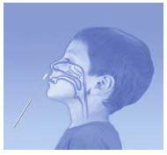

1. Insert the swab into one nostril of the patient.



1. Rotate the swab two (2) complete 360-degree turns; pressing firmly against the nasal mucosa to help ensure the swab obtains both cells and mucus.

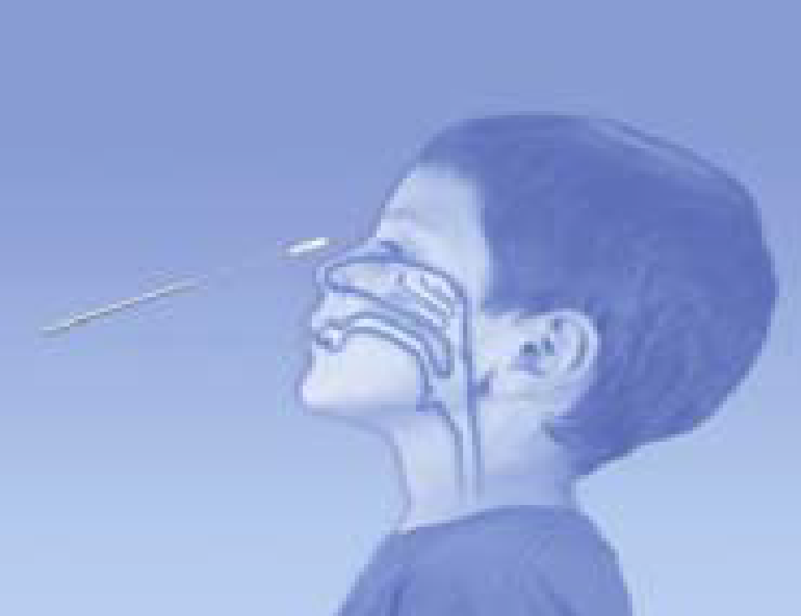

1. Withdraw the swab from the nasal cavity. The sample is now ready for processing using the BD Veritor System Kit.

**PROPER NASOPHARYNGEAL SWAB SAMPLE COLLECTION**

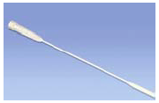

1. The BD Veritor System Kit includes swabs with a flocked nylon tip

for nasopharyngeal specimen collection.



1. Insert the swab into one nostril of the patient, reaching the surface of the posterior nasopharynx.

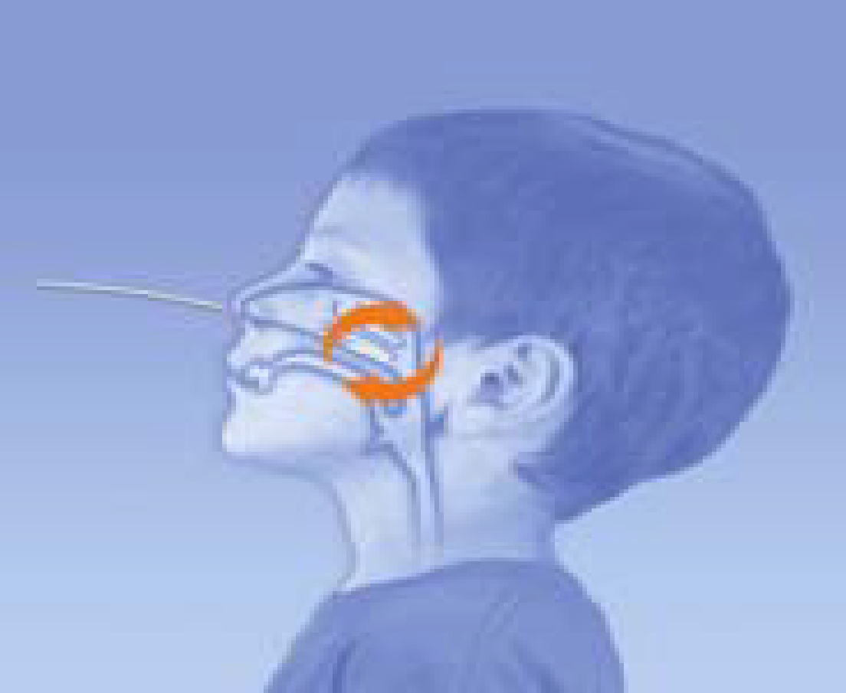

1. Rotate the swab over the surface of the posterior nasopharynx.



1. Withdraw the swab from the nasal cavity. The sample is now ready for processing using the BD Veritor System Kit.

***NOTE:*** *THE DO’S AND DON’TS OF SAMPLE COLLECTION:*

* *Do collect sample as soon as possible after onset of symptoms*
* *Do test sample immediately*
* *BD recommends flocked swabs which are provided in the BD Veritor System Flu A+B Kit*
* *Do not use cotton tips and wooden shafts*
* *Do not use calcium alginate swabs*

**Electronic Authorizations:**

Michael Zur, MD, Medical Director of Laboratory

Kelly Cwikla, MT(ASCP)SM, Clinical Manager of Microbiology